CLOUD - DATA - GENAI LEARNING PATH

Day 10 - Terraform on Azure
Detailed Lab Guide: Infrastructure as Code, Remote State, Maps/Lookups and Linux VM Deployment
Day 10 TOC alignment: This lab maps to Infrastructure as Code, Terraform providers/resources, maps/lookups, remote state on Azure, Terraform scripts, troubleshooting/testing, best practices and the practical exercise to deploy a Virtual Machine using Terraform.

14-student tenant model: Students must use only their assigned resource group. Trainer should pre-register required Azure resource providers and prepare any shared remote state storage if students do not have subscription-level permissions.

1. Learning Outcomes
- Explain why Infrastructure as Code is used in private and public cloud environments.
- Understand Terraform core workflow: init, fmt, validate, plan, apply, output, destroy.
- Write Terraform provider, resource, variable, output and backend blocks.
- Use maps and lookups to select region, VM size, and tags consistently.
- Configure remote Terraform state using Azure Storage.
- Deploy a Linux VM with VNet, subnet, NSG, NIC, Public IP, cloud-init and NGINX.
- Troubleshoot provider registration, RBAC, backend, state lock, naming, quota and VM access issues.
- Explain best practices for Terraform in teams and CI/CD pipelines.
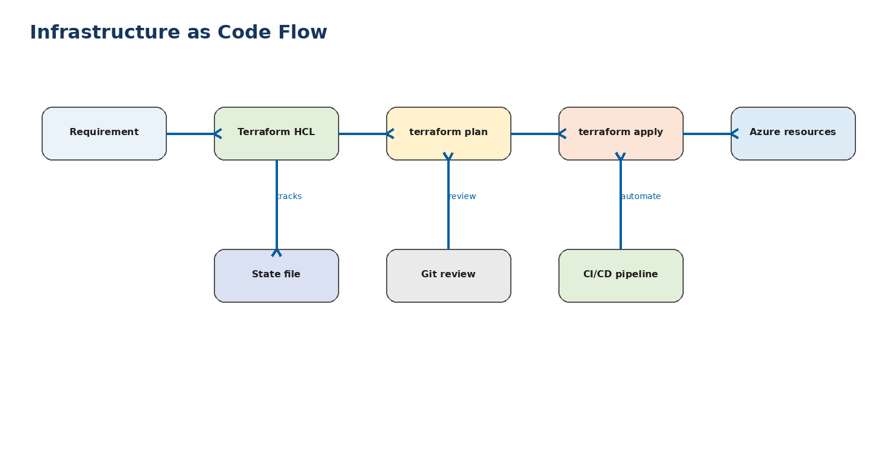
Figure 1 - Infrastructure as Code delivery flow.

2. Trainer Pre-Lab Checklist
- Confirm the Azure subscription is active and cost-controlled.
- Confirm every student can sign in to the training tenant.
- Confirm each student has Contributor only on the assigned resource group, such as rg-cdg-s06.
- Register required providers at subscription level using trainer/admin account: Microsoft.Compute, Microsoft.Network, Microsoft.Storage.
- Check regional quota for small VMs and public IPs.
- Decide whether remote state storage is shared by trainer or created individually by each team.
- Prepare one completed trainer demo so students can compare their outputs.
- Ask students to use Bash Cloud Shell, not PowerShell, for the provided commands.
# Trainer/admin provider pre-check
az provider show --namespace Microsoft.Compute --query registrationState -o tsv
az provider show --namespace Microsoft.Network --query registrationState -o tsv
az provider show --namespace Microsoft.Storage --query registrationState -o tsv
# Register if required
az provider register --namespace Microsoft.Compute
az provider register --namespace Microsoft.Network
az provider register --namespace Microsoft.Storage

3. Lab Naming Convention
Item | Pattern | Student06 example
Resource group | rg-cdg-sNN | rg-cdg-s06
Terraform folder | day10-terraform-vm | ~/day10-terraform-vm
VNet | vnet-cdg-sNN | vnet-cdg-s06
Subnet | snet-web | snet-web
NSG | nsg-cdg-sNN-web | nsg-cdg-s06-web
Public IP | pip-cdg-sNN | pip-cdg-s06
NIC | nic-cdg-sNN | nic-cdg-s06
Linux VM | vm-cdg-sNN | vm-cdg-s06
State key | day10/studentNN/terraform.tfstate | day10/student06/terraform.tfstate

4. Detailed Hands-on Lab Steps
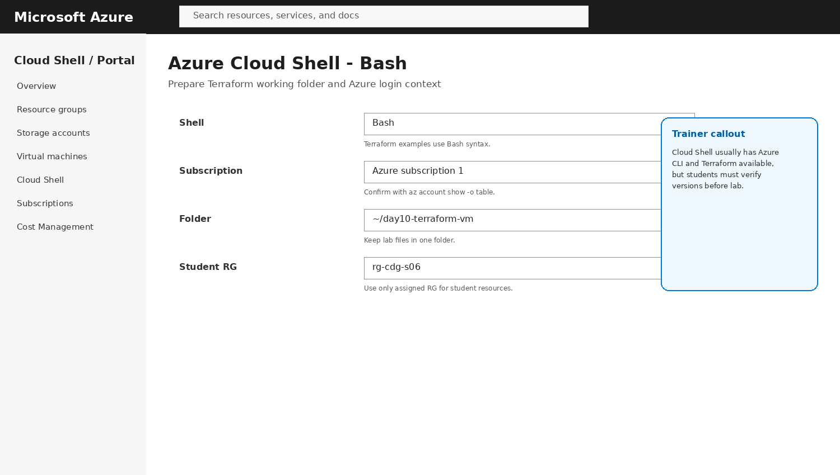
Figure 2 - Cloud Shell setup for Day 10 Terraform lab.
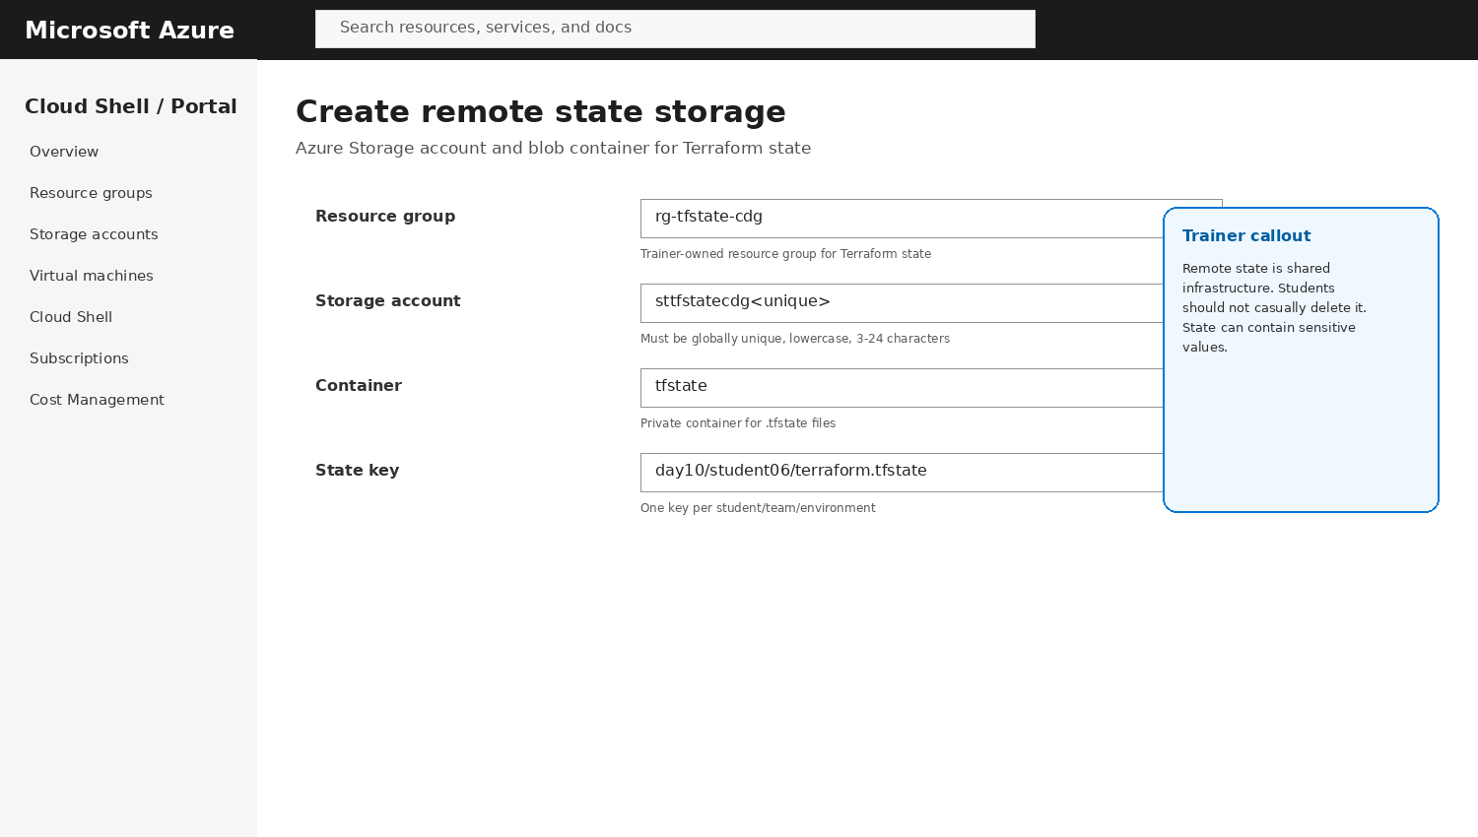
Figure 3 - Remote state storage concept and values.
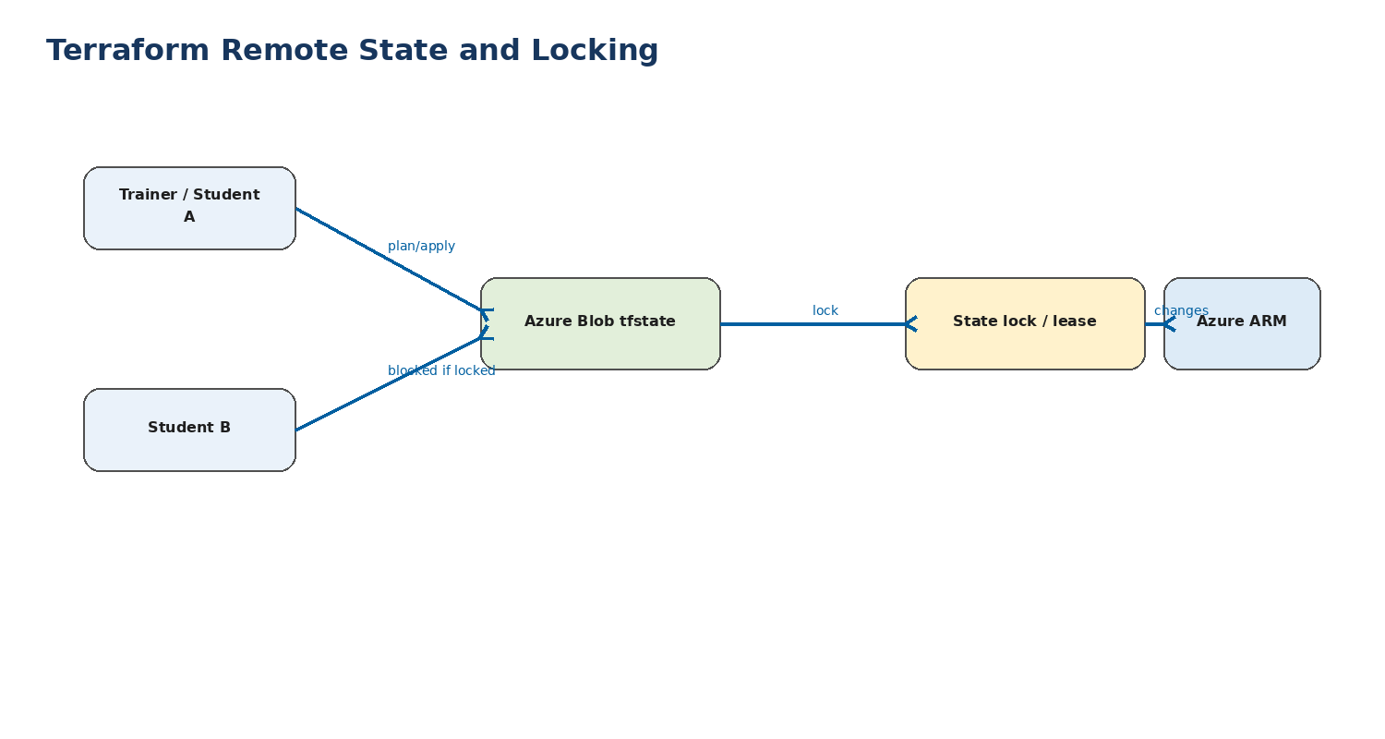
Figure 4 - Remote state and locking concept.
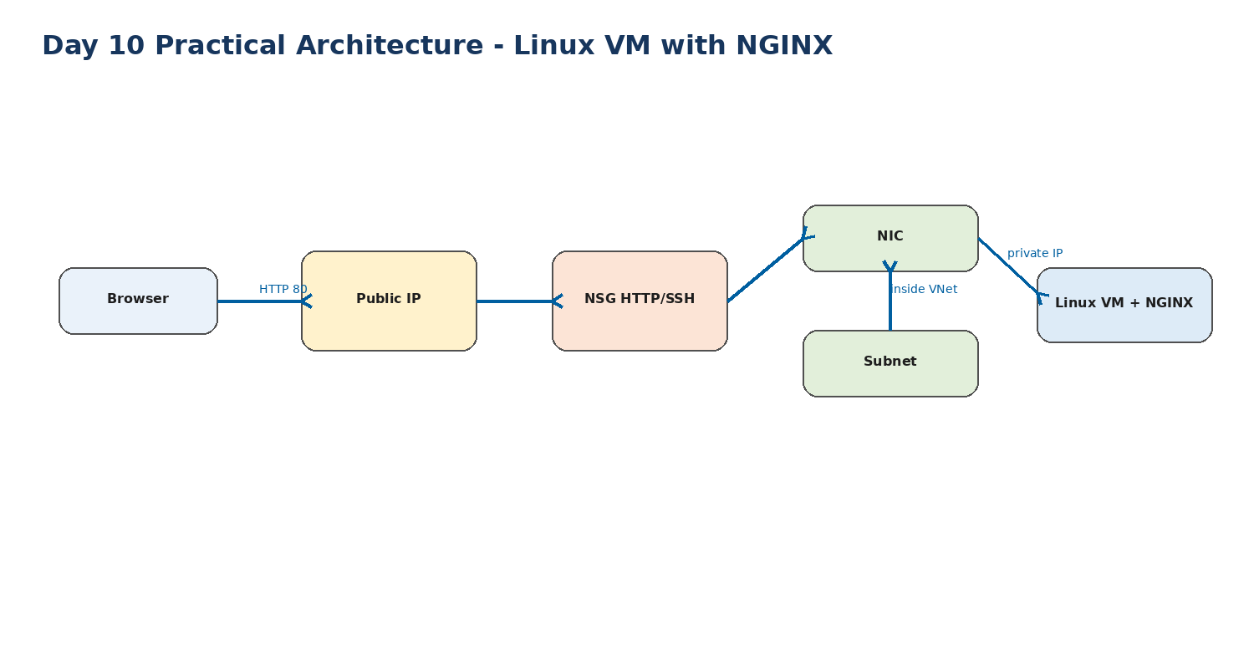
Figure 5 - Final VM lab architecture.

Lab 10.1 - Verify Azure and Terraform CLI
- Open Azure Portal and start Cloud Shell.
- Select Bash, not PowerShell.
- Run az account show -o table and confirm correct tenant/subscription.
- Run terraform -version.
- Create a folder: mkdir -p ~/day10-terraform-vm && cd ~/day10-terraform-vm.
az account show -o table
terraform -version
mkdir -p ~/day10-terraform-vm
cd ~/day10-terraform-vm
pwd

Lab 10.2 - Understand Terraform Project Files
- Create one folder per lab.
- Use main.tf for resources, variables.tf for inputs, outputs.tf for useful values, providers.tf for provider settings, backend.tf for remote state.
- Explain that Terraform reads all .tf files in the folder together.
day10-terraform-vm/
backend.tf
providers.tf
variables.tf
locals.tf
main.tf
outputs.tf
cloud-init.tpl

Lab 10.3 - Prepare Remote State Storage
- Trainer may pre-create a shared storage account and provide the state resource group, storage account and container name.
- Students create a unique backend key for their own state file.
- Explain that local state is not safe for a team because it can be lost or overwritten.
# Example trainer-created backend values
STATE_RG=rg-tfstate-cdg
STATE_STORAGE=sttfstatecdg12345
STATE_CONTAINER=tfstate
STATE_KEY=day10/student06/terraform.tfstate

Lab 10.4 - Create providers.tf
- Define the required Terraform version and AzureRM provider.
- Use features {} block because AzureRM provider requires it.
- Use Azure CLI authentication from Cloud Shell.
terraform {
required_version = ">= 1.6.0"
required_providers {
azurerm = {
source = "hashicorp/azurerm"
version = "~> 4.0"
}
}
}
provider "azurerm" {
features {}
}

Lab 10.5 - Create backend.tf
- Add an azurerm backend block.
- Backend block values can be hardcoded for the lab or supplied during terraform init.
- Remote state should use a unique key per student/team.
terraform {
backend "azurerm" {
resource_group_name = "rg-tfstate-cdg"
storage_account_name = "sttfstatecdg12345"
container_name = "tfstate"
key = "day10/student06/terraform.tfstate"
}
}

Lab 10.6 - Create variables.tf
- Define inputs for student number, resource group, location, admin username and SSH source IP.
- Use validation where useful.
- Keep values reusable rather than hardcoding everywhere.
variable "student_id" {
description = "Student number such as s06"
type = string
default = "s06"
}
variable "resource_group_name" {
description = "Assigned resource group"
type = string
default = "rg-cdg-s06"
}
variable "location" {
description = "Azure region"
type = string
default = "southindia"
}
variable "admin_username" {
type = string
default = "azureuser"
}
variable "allowed_ssh_source" {
description = "Use your public IP as CIDR, example 203.0.113.25/32"
type = string
default = "0.0.0.0/0"
}

Lab 10.7 - Use maps and lookups in locals.tf
- Create maps for VM size and tags.
- Use lookup to select defaults safely.
- Explain maps and lookups as configuration-driven design.
locals {
vm_size_by_env = {
dev = "Standard_B1s"
qa = "Standard_B1ms"
}
common_tags = {
project = "day10-terraform"
owner = var.student_id
env = "dev"
}
selected_vm_size = lookup(local.vm_size_by_env, "dev", "Standard_B1s")
}

Lab 10.8 - Create cloud-init.tpl
- Use cloud-init to install NGINX automatically.
- Write a student-specific HTML page.
- This validates both VM provisioning and application bootstrap.
#cloud-config
package_update: true
packages:
- nginx
write_files:
- path: /var/www/html/index.html
content: |
<html><body>
<h1>Day 10 Terraform VM</h1>
<h2>Student: ${student_id}</h2>
<p>Provisioned using Terraform on Azure.</p>
</body></html>
runcmd:
- systemctl enable nginx
- systemctl restart nginx

Lab 10.9 - Create main.tf infrastructure
- Use a data source for existing assigned resource group or create a resource group only if trainer allows it.
- Create VNet, subnet, public IP, NSG, NIC and Linux VM.
- Use custom_data with cloud-init to install NGINX.
data "azurerm_resource_group" "lab" {
name = var.resource_group_name
}
resource "azurerm_virtual_network" "vnet" {
name = "vnet-cdg-${var.student_id}"
address_space = ["10.60.0.0/16"]
location = data.azurerm_resource_group.lab.location
resource_group_name = data.azurerm_resource_group.lab.name
tags = local.common_tags
}
resource "azurerm_subnet" "web" {
name = "snet-web"
resource_group_name = data.azurerm_resource_group.lab.name
virtual_network_name = azurerm_virtual_network.vnet.name
address_prefixes = ["10.60.1.0/24"]
}
resource "azurerm_public_ip" "pip" {
name = "pip-cdg-${var.student_id}"
location = data.azurerm_resource_group.lab.location
resource_group_name = data.azurerm_resource_group.lab.name
allocation_method = "Static"
sku = "Standard"
tags = local.common_tags
}
resource "azurerm_network_security_group" "nsg" {
name = "nsg-cdg-${var.student_id}-web"
location = data.azurerm_resource_group.lab.location
resource_group_name = data.azurerm_resource_group.lab.name
tags = local.common_tags
}
resource "azurerm_network_security_rule" "allow_http" {
name = "Allow-HTTP"
priority = 100
direction = "Inbound"
access = "Allow"
protocol = "Tcp"
source_port_range = "*"
destination_port_range = "80"
source_address_prefix = "*"
destination_address_prefix = "*"
resource_group_name = data.azurerm_resource_group.lab.name
network_security_group_name = azurerm_network_security_group.nsg.name
}
resource "azurerm_network_security_rule" "allow_ssh" {
name = "Allow-SSH-Training"
priority = 110
direction = "Inbound"
access = "Allow"
protocol = "Tcp"
source_port_range = "*"
destination_port_range = "22"
source_address_prefix = var.allowed_ssh_source
destination_address_prefix = "*"
resource_group_name = data.azurerm_resource_group.lab.name
network_security_group_name = azurerm_network_security_group.nsg.name
}
resource "azurerm_subnet_network_security_group_association" "web" {
subnet_id = azurerm_subnet.web.id
network_security_group_id = azurerm_network_security_group.nsg.id
}
resource "azurerm_network_interface" "nic" {
name = "nic-cdg-${var.student_id}"
location = data.azurerm_resource_group.lab.location
resource_group_name = data.azurerm_resource_group.lab.name
ip_configuration {
name = "ipconfig1"
subnet_id = azurerm_subnet.web.id
private_ip_address_allocation = "Dynamic"
public_ip_address_id = azurerm_public_ip.pip.id
}
tags = local.common_tags
}
resource "azurerm_linux_virtual_machine" "vm" {
name = "vm-cdg-${var.student_id}"
resource_group_name = data.azurerm_resource_group.lab.name
location = data.azurerm_resource_group.lab.location
size = local.selected_vm_size
admin_username = var.admin_username
network_interface_ids = [azurerm_network_interface.nic.id]
admin_ssh_key {
username = var.admin_username
public_key = file("~/.ssh/id_rsa.pub")
}
os_disk {
caching = "ReadWrite"
storage_account_type = "Standard_LRS"
}
source_image_reference {
publisher = "Canonical"
offer = "0001-com-ubuntu-server-jammy"
sku = "22_04-lts-gen2"
version = "latest"
}
custom_data = base64encode(templatefile("${path.module}/cloud-init.tpl", {
student_id = var.student_id
}))
tags = local.common_tags
}

Lab 10.10 - Create outputs.tf
- Output the public IP and application URL.
- Outputs make the deployment easier to validate and easier for pipelines to consume.
output "public_ip_address" {
value = azurerm_public_ip.pip.ip_address
}
output "application_url" {
value = "http://${azurerm_public_ip.pip.ip_address}"
}
output "vm_name" {
value = azurerm_linux_virtual_machine.vm.name
}

Lab 10.11 - Initialize and validate Terraform
- Run terraform init to download providers and configure remote state.
- Run terraform fmt to format files.
- Run terraform validate to detect syntax and provider errors.
terraform init
terraform fmt -recursive
terraform validate

Lab 10.12 - Generate and review plan
- Run terraform plan and save a plan file.
- Review add/change/destroy counts.
- Explain that plan is a preview, not a deployment.
terraform plan -out=tfplan

Lab 10.13 - Apply the infrastructure
- Run terraform apply tfplan.
- Wait until Azure resources are created.
- Capture outputs.
terraform apply tfplan
terraform output
terraform output -raw application_url

Lab 10.14 - Validate VM and NGINX
- Open the application_url output in a browser.
- Confirm the page shows Day 10 Terraform VM and the student id.
- If not reachable, verify NSG, public IP, VM status, NGINX and cloud-init logs.
APP_URL=$(terraform output -raw application_url)
echo $APP_URL
curl -I $APP_URL

Lab 10.15 - Make a controlled change
- Change a tag or VM page content.
- Run terraform plan again.
- Explain what Terraform will update and why.
# Example: add a new tag in locals.tf, then run
terraform fmt
terraform plan
terraform apply

Lab 10.16 - Destroy resources after validation
- Run terraform destroy only when trainer approves.
- Confirm all resources are removed.
- Do not delete shared backend storage unless trainer instructs.
terraform destroy
# Confirm resources in Azure Portal Resource Group

5. Troubleshooting Guide
Symptom | Likely cause | Fix
AuthorizationFailed on provider register | Student has only resource-group Contributor; provider registration is subscription-level | Trainer registers provider once using subscription-level account.
terraform init backend fails | Wrong storage account/container/key or insufficient storage permission | Verify backend values and student access. Trainer can preconfigure backend.
State lock error | Another apply is running or previous run failed while holding lock | Wait, identify owner, then use force-unlock only with trainer approval.
VM size not available | Region quota or SKU restriction | Use trainer-approved alternate size or region.
Public IP quota exceeded | Training/free subscription quota limitation | Reuse resources, reduce parallel deployments, or ask trainer to increase quota.
Website not opening | NGINX failed, NSG blocks HTTP, public IP not ready | Check terraform output, NSG rule, VM boot diagnostics/cloud-init logs.
SSH not working | Wrong key, NSG blocks 22, username mismatch | Check admin_username, public key, source IP and NSG rule.
Plan wants to replace VM | Changing immutable property like image or OS disk | Explain ForceNew behavior and confirm before apply.
Resource already exists | Name collision or previously created portal resource | Use unique names or import existing resource if advanced.
Destroy fails | Locks, permissions or dependent resources | Check Azure locks/RBAC and dependency errors.

6. Terraform with Azure DevOps Pipeline - Conceptual Demo
trigger:
- main
pool:
vmImage: ubuntu-latest
steps:
- checkout: self
- task: TerraformInstaller@1
inputs:
terraformVersion: latest
- task: AzureCLI@2
inputs:
azureSubscription: 'training-service-connection'
scriptType: bash
scriptLocation: inlineScript
inlineScript: |
terraform init
terraform fmt -check
terraform validate
terraform plan -out=tfplan
terraform apply -auto-approve tfplan
Trainer explanation: Do not make Azure DevOps mandatory if the batch is using GitHub. Show it as the enterprise equivalent: pipeline runner authenticates to Azure, runs init/validate/plan/apply, and uses remote state.

7. Best Practices Summary
- Keep Terraform code in source control and review through pull requests.
- Use remote state for shared/team work; do not email or manually copy state files.
- Use one state file per environment or bounded stack, not one giant state for everything.
- Never store secrets in .tfvars committed to Git.
- Use variables, maps and naming standards instead of copy-paste hardcoding.
- Run fmt and validate in every pipeline.
- Always review plan before apply in real environments.
- Protect production apply with approvals.
- Use least-privilege service principals/workload identity for pipelines.
- Tag resources for owner, environment, project and cleanup.
- Clean up lab resources to control cost.

8. Student Deliverables
- Screenshot of terraform version and az account show.
- Screenshot or copy of project file tree.
- Screenshot of successful terraform init, validate, plan and apply.
- Screenshot of Azure resource group showing VNet, NSG, Public IP, NIC and VM.
- Browser screenshot of NGINX page.
- Screenshot of terraform output.
- One troubleshooting note explaining an error and fix.
- Screenshot of terraform destroy or confirmation of trainer-approved retention.

